# SOP - Change Metadata - EP, Code Roll, MFE, etc

* Experiment (EP)
  + How to find a ServiceNow Change ticket for a corresponding EP - aka "Is this EP event missing from our transactions/chart?"
  + How to find an EP based on placementId - aka "Is this placementId missing from our EP Changes?"
* Merch Front End (MFE)
  + How to find a ServiceNow Change ticket for a corresponding MFE - aka "Is this MFE event missing from our transactions/chart?"

<https://adsshepherd.muse.vip.ebay.com/controlcenter/metadata/changes> and on Core Metrics "Show Changes"

Currently supports

* Experimentation changes (touchstone)
* MFE
* Code Rollout and rollback for Raptor.io, Raptor, NodeJS for Ads owned pools

# Experiment (EP)

## How to find a ServiceNow Change ticket for a corresponding EP - aka "Is this EP event missing from our transactions/chart?"

1. Go to ServiceNow <https://ebayinc.service-now.com/navpage.do>
2. Navigate to Change Requests - in SNOW side menu, click **All Applications** (box icon) > **Self-Service** > **Change Requests**



1. Filter by Experiments - in the filter section

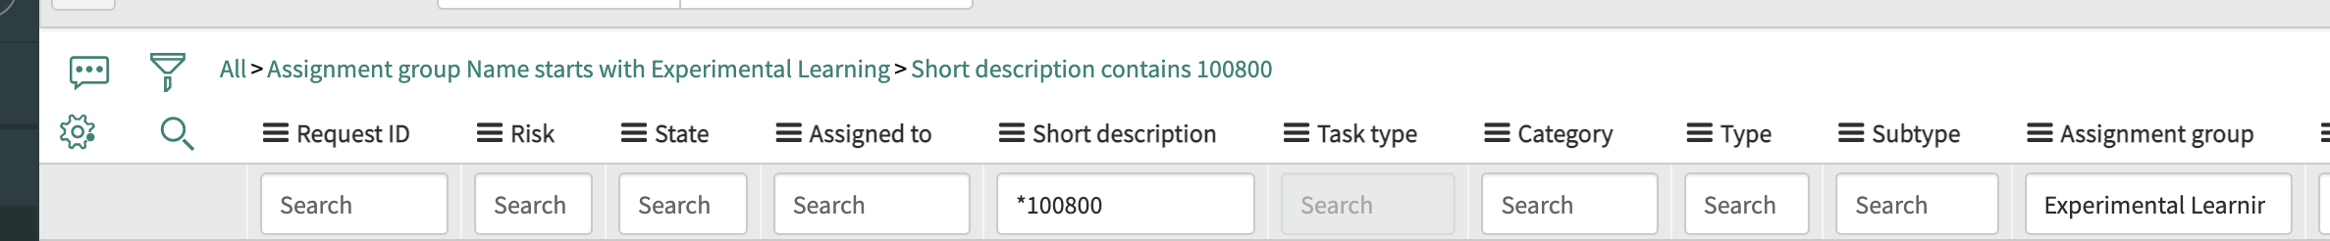

* 1. Click **All**(this is to remove the **Active = true** filter)
  2. Type **Experimental Learning** in Assignment Group column
  3. Type **\*{EPID}** in Short description column (i.e. *100800)

1. If EP CR is in SNOW but **NOT** available in Control Center, contact Clark Ngo (Ngo, Clark Jason Bautista(AWF)) cc #shepherd-support
2. If EP CR is **NOT** in SNOW, file a troubleshooting ticket at <https://go/ep911> ~~contact Wenjun Si (@wesi) cc #experimentation-support~~

Sample URL:

<https://ebayinc.service-now.com/nav_to.do?uri=%2Fchange_request_list.do%3Fsysparm_query%3Dassignment_group.nameSTARTSWITHExperimental%2520Learning%255Eshort_descriptionLIKE100800%26sysparm_first_row%3D1%26sysparm_view%3D%26sysparm_choice_query_raw%3D%26sysparm_list_header_search%3Dtrue>

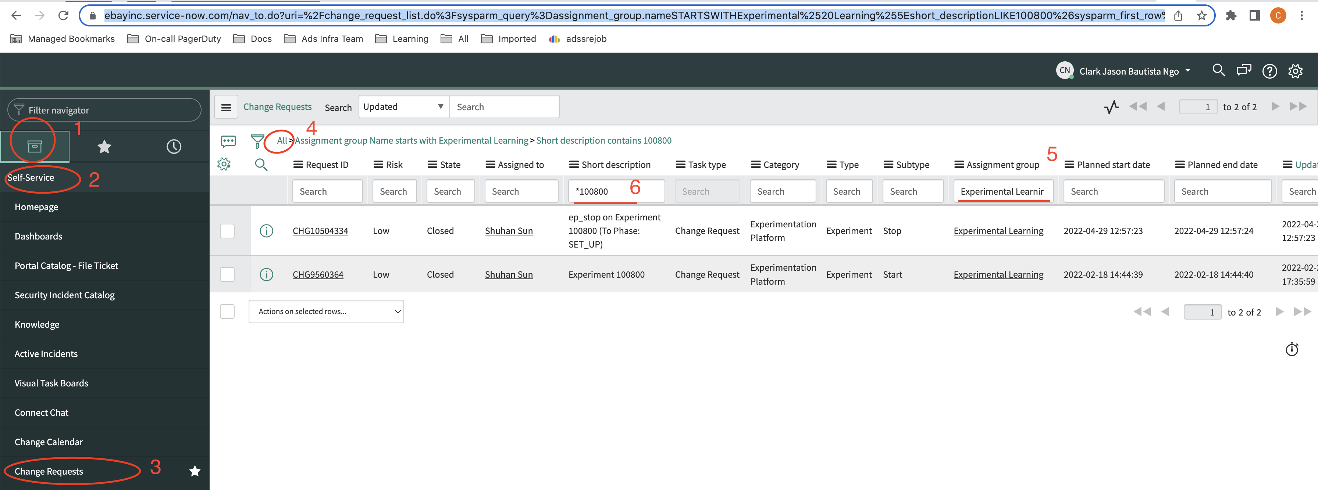

Reason for no EP CRs in SNOW on April 28, 2022, the CRs of experiment/s failed to create due to MMI request failure to SNOW.

MMI:

<https://wiki.vip.corp.ebay.com/display/MMI/MMI+Home>

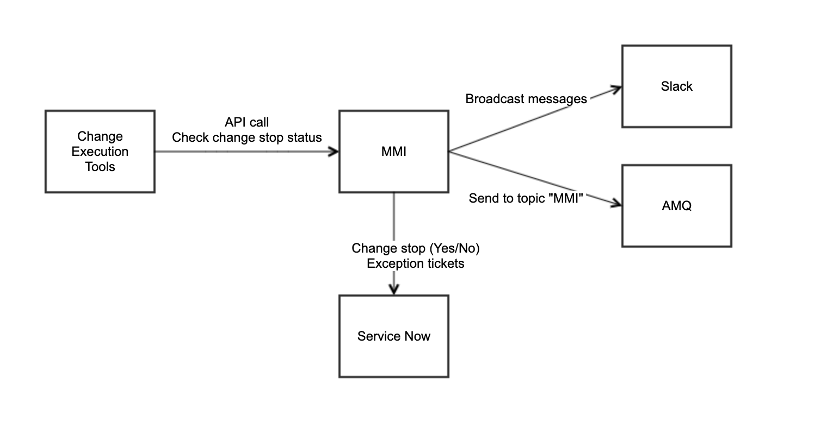

## How to find an EP based on placementId - aka "Is this placementId missing from our EP Changes?"

If you don't see a specific known or suspected experiment or experiment change event (aka traffic ramp up/down) on the Control Center [changes](https://adsshepherd.muse.vip.ebay.com/controlcenter/metadata/changes) dashboard, you can search for it in touchstone

|  |  |
| --- | --- |
| 1. Go to Touchstone <https://touchstone.vip.ebay.com/> |  |
| 2. Search with placementId in the upper right search box |  |
| 3. Change View Experiments to All and update Start and End Dates as needed |  |
| 4. This will return a list of Experiments where you can confirm the Experiment as desired |  |
| a. Open Experiment and Select Design Tab |  |
| b. Scroll down for Factor to confirm placementId |  |
| c. Select Audit Logs to view EP state changes, including data collection when it starts to take traffic where "Served Traffic Percentage != 0" and "Experiment Status" is Active |  |

# Merch Front End (MFE)

## How to find a ServiceNow Change ticket for a corresponding MFE - aka "Is this MFE event missing from our transactions/chart?"

MFE in Service Now:

<https://ebayinc.service-now.com/nav_to.do?uri=%2Fchange_request_list.do%3Fsysparm_fixed_query%3D%26sysparm_query%3Dassigned_to.nameSTARTSWITHMFE%2520Service%2520Account%255Eassigned_to%253D69d56947dbb87410e6be3dc4e2961979%26sysparm_view%3D%26sysparm_clear_stack%3Dtrue>

Contacts: MFE Tools contact pesons: Fengfu Li, Padmapriya Srinivasan